

**Technical Answers for Real World Problems (TARP)**

**CSE1901**

**AgriEasy - Harvesting the Future of Agriculture**

In partial fulfilment for the award of the degree of B. Tech in Computer Science and Engineering

**Submitted by:**

Anish Shrestha (20BCE2893)

Bijan Shrestha(20BCE2904)

Bisuraj Sharma (20BCE2923)

Sumit Kumar Mandal (20BCE2885)

Ujjwal Tiwari (20BCE0415)

Under the Guidance of

**Prof. Rajkumar S**

**Winter Semester 2022-23**

**AgriEasy: Harvesting the Future of Agriculture**

##### **Bisuraj Sharma*, Ujjwal Tiwari**, Bijan Shrestha**, Anish Shrestha**, Sumit Kumar Mandal\*\***

#Scope – Vellore Institute of Technology

**Abstract***-* The internet and telecommunications technology have transformed the agricultural landscape, providing farmers with a range of resources to improve their operations. One of the significant challenges in agriculture is plant diseases, which can significantly reduce crop yields and economic returns. In this study, we developed a plant disease detection model utilizing the Plant Village dataset, which contains 54,000 images of 14 different crop species, including tomato, corn, wheat, and potato. Our model is based on a finely tuned Resnet50 architecture and outperformed other popular models, such as Normal CNN, Inception V3, and VGGnet, in accurately identifying various forms of crop illnesses. Plant disease detection models can assist farmers in identifying potential crop issues early on, allowing for timely interventions and reducing economic losses. Our study highlights the importance of plant disease detection models in improving agricultural productivity and economic returns.

Keywords— **Agriculture, Convolutional Neural networks (CNN), Image Recognition, Machine Learning, Plant disease detection, Resnet50, Transfer Learning.**

1. **Introduction**

Agriculture has long been the backbone of human civilization, providing sustenance and nourishment to billions of people around the world. In fact, over 90% of the global population is in some way associated with farming, making it a crucial industry for our survival. However, the very foundation of our food security is now under threat from a range of factors, such as climate change, the decline of pollinators, and the emergence of plant diseases. These diseases not only endanger the safety of our food but can also lead to disastrous consequences for farmers, who are often forced to expend vast amounts of resources in order to prevent their crops from succumbing to illness, some plant diseases are difficult to recognize with the naked eye, which can make it extremely challenging for farmers to take the necessary preventative measures.

Farmers can employ a lot of techniques, including crop rotation, the adoption of disease-resistant cultivars, and chemical or biological pest control techniques, to reduce the impact of plant diseases on agriculture [1]. Early disease identification can reduce crop losses and prevent the disease from spreading to adjacent plants. Early disease detection allows farmers to adopt appropriate control measures, such as using pesticides or other control measures, which can assist to lessen the disease's negative effects on crop production. Additionally, by preventing the spread of harmful microorganisms and reducing the demand for pesticides, the recognition of plant illnesses can contribute to the protection of the environment and human health [2].

The preservation of a plant is important for the growth of the entire nation. So, an effective system needs to be developed to protect the plant from various diseases. According to the research, farmers usually consult agricultural scientists and experts before making decisions. Living in rural areas makes it difficult for agricultural scientists to communicate with farmers. The intention is to for the detection and recognition of agricultural diseases in order to solve these issues [3]. In comparison to other machine learning-based model, manual disease identification by farmers is time-consuming and less accurate. By providing farmers a convenient and accessible tool for identifying and diagnosing plant issues, efficient ML model can play a crucial role in the identification of plant diseases. Farmers may provide a dataset of sick leaves and use the application to process them, improving the whole treatment process. AgriEasy, a trained model [4], has been developed to help farmers in dealing with their problems and preventing crop loss. Later the model can be integrated and fetched through different effective modes so that farmers simply need to provide disease plants dataset digitally to identify it and discover it much earlier. If the crop is infected, farmers may spare the crops from being destroyed and increase agricultural production by taking preventive measures.

The Machine Learning based image processing approach is used for the identification of diseases in plants based on symptoms that arise on leaves. The disease identified by the project includes bacterial leaf blast, neck blast, leaf scald, false smut and many more. This system is expected to be more accurate as compared to the existing ones so that it can help farmers to identify diseases in different plants precisely and treat them effectively. To help farmers address their difficulties and prevent loss of agricultural production. So, to detect disease much earlier, farmers simply need to provide a diseased data set and its parameter in validation set and diagnose it; if the crop is diseased, farmers may save the crops from destruction and boost agricultural yield by following the preventive measures.

Furthermore, Using the trained model farmer can quickly and accurately identify diseased plants in their fields, which can help them take proactive measures to prevent the spread of the disease and minimize crop losses. Early detection of plant diseases is crucial for farmers because it allows them to take action before the damage becomes severe. With the help of ResNet-50, farmers can save time and resources by identifying and treating diseased plants more efficiently. The trained model can further be implemented to different portal such as web app, mobile applications etc. by loading the saved trained model in the database where farmer can have easy access and detect the plant disease effectively. With an early detection or prediction of the disease, it can be solved and mitigate the problem easily and effectively.

1. **Related work**

Recognition of plant diseases has been a topic of discussion for many years. With the use of machine learning techniques, several researchers have created numerous appropriate architectures and contributed their ideas to the detection of plant diseases.

Yatoo, A. A., & Sharma, A. (2021) [5]. In this paper, the performance of a Fine-tuned CNN-based model using the optimizer Stochastic Gradient Descent (SGD) and VGG16 was compared to identify the diseases, scab and cedar apple rust, the models were trained using publicly available The Plant Pathology Data Set 2020 was used which comprises a total of 3,651 high-quality, real-life symptom leaf photos. The results of the experiments show how the recommended model works better than VGG16 with 85% accuracy. The authors of [6] presents a study on image classification using a 5-layer deep convolutional neural network (CNN) for recognizing four types of plant diseases. The dataset used in the study included images of anthracnose, downy mildew, powdery mildew, and target leaf spots collected from online sources. The study evaluated the performance of the deep CNN using accuracy measurements and compared it with the conventional classifiers and AlexNet. The results showed an accuracy of 93.4% on the unbalanced dataset and 92.2% on the balanced dataset.

According to the study [7], an effective deep learning model with three parts—a backbone network, a bi-FPN network, and a class/box prediction network—can be used to identify plant leaf diseases. Images of four distinct plant species with five distinct illnesses are included in the dataset used to train and test the CNN. Using a number of criteria, including accuracy, precision, recall, and F1 score, the proposed system is assessed and contrasted with the current plant disease detection methods. Using pre-trained convolution neural network (CNN) models for the extraction and support vector machine (SVM) for classification, Agarwal, P., & Reddy, M. J. (2019) [8] underlined the significance of early identification of plant diseases for averting large crop losses. Using a collection of plant photos, including those with healthy plants and those with various illnesses, such as bacterial blight and powdery mildew, they trained and tested their system, achieving 96% accuracy.

Syed-Ab-Rahman, S.F., Hesamian, M.H. & Prasad, M. (2022) [9], This paper describes a deep convolutional neural network based on Faster R-CNN, which has four components, used to classify citrus leaves into four categories: black spot, Huanglongbing, canker, and healthy. The network was trained on a Kaggle dataset consisting of 477 training samples and 127 test samples, with images in PNG format and size of 256x256. The results showed high performance accuracy, with 86.2% for black spot, 97.2% for canker, and 94.6% for Huanglongbing. M. Kathiravan, K. H. Priya, S. Sreesubha, A. Irumporai, V. S. Kumar, and V. V. Reddy [10], This paper uses OpenCV to preprocess images and a convolutional neural network in TensorFlow for deep learning to classify different diseases in a dataset of paddy, guava, and cotton called Kaggle Fruits 360. The dataset used for experimentation is 90k, and the proposed model achieves an accuracy of 93.3%, which is better than other ML methods such as SVM, KNN, and ANN.

In [11] The paper proposed Two-channel Convolutional Neural Network was built using elements from VGG and ResNet models to identify instances of maize leaf disease. Three datasets representing different types of leaf diseases (big spot, gray leaf spot, and rust) were obtained from the "kaggle" website. The network's validation accuracy ultimately reached 98.33%, and the loss incurred during testing was 0.07628. Mondal, Joyanta & Islam, Md & Zabeen, Sarah & Islam, A. B. M. Alim Al & Noor, Jannatun. (2022) [12] The paper presents a new Deep CNN architecture that is lightweight and does not use transfer learning. The method is tested on the Plant Village dataset which contains 54,303 leaf images divided into 38 categories based on species and disease. The proposed method achieves an accuracy of 98.18%, which is higher than VGG-16 However, it should be noted that this method is limited to leaf disease detection and a smaller number of categories.

Ullah, F., Khan, R. U., Khan, K., Albattah, W., & Qamar, A. M. (2021). [13] The paper proposed a CNN model that combines computer vision (CV) to categorize various layers of damaged leaves. The study employed the Plantvillage dataset, which included 54303 images of unhealthy and healthy leaves, classified into 38 categories by disease and species. The proposed approach achieved an average final accuracy of 0.938. However, the study identified some limitations such as database availability and size, feature extraction methods, classification module difficulties, and the constraints of existing systems. Jiang, F., Lu, Y., Chen, Y., Cai, D., & Li, G. (2020) [14]. The paper present how to use deep learning and support vector machine (SVM) techniques to precisely detect four "common rice leaf diseases" (rice blast, bacterial leaf blight, brown spot, and leaf streak). Four different diseases—rice blast, rice bacterial spot, rice streak leaf spot, and rice sheath blight—were present in a collection of 8911 images of rice leaves. These images were split into training and testing sets, and a deep learning approach based on CNN was used to extract features from the images before SVM was used to classify the images into various disease categories. The findings indicated that the suggested approach outperformed numerous other methods that were examined in the study, achieving an accuracy of 96.83% on the testing set.

*Table 1. Comparison*

|  |  |  |  |  |
| --- | --- | --- | --- | --- |
| **RefNo.** | **Methodology** | **Datasets** | **Performance Measures** | **Limitation** |
| [5] | Fine-tuned CNN, Stochastic Gradient Descent (SGD), VGG16. | [The Plant Pathology Dataset 2020](https://www.kaggle.com/c/plant-pathology-2020-fgvc7/data) | Recall- 0.85, Accuracy- 0.85, F1-Score- 0.85, Average Score 735,  Accuracy = (85%) | A software application is needed,  The model could not generalize to other forms of plant diseases. |
| [6] | 5 Layers CNN, DCNNs, AlexNet and conventional classifiers. | [Plant Village Dataset](https://plantvillage.psu.edu/), and [Forestry Images Dataset](https://www.forestryimages.org/) | Precision- 92.18%, Accuracy- 93.4% and 92.2% | Limited Dataset,  Not able to generalize to different types leaf symptoms or diseases. |
| [7] | Efficient De deep learning model, Backbone Network, BiFPN Network, and Class/ Box Prediction  Network | [PlantVillage Dataset](https://www.tensorflow.org/datasets/catalog/plant_village) | Precision- 88.13%, Recall- 94.06% and F1-score is 90.99%, Accuracy- 74.10% | The crop species which are trained are less. |
| [8] | YOLOv3,  Simple Classifier,  VGGNet,  Transfer Learning with ResNet. | [PlantVillage Dataset](https://www.tensorflow.org/datasets/catalog/plant_village) | Accuracy- 96% | It does not provide specific details about the type of model used for leaf classification or the dataset it was trained on. |
| [9] | Faster R-CNN. (RPN), (ROI) pooling and classifier. | [Citrus leave prepared Dataset](https://www.kaggle.com/dtrilsbeek/citrus-leaves-prepared?select=citrus_leaves_prepared) | F1-score -(90, 97.9, 93.0), Precision- (93.8, 99.0, 91.0), Recall- (87, 95.8, 94.6), Accuracy- (86.18, 97.2, 94.64) for blackspot, Canker, Huanglogbing, respectively. | Improvement on robustness , reduce the standard deviation. |
| [10] | convolutional neural network using TensorFlow for deep learning. | [The Kaggle Fruits 360 Dataset](https://www.kaggle.com/datasets/moltean/fruits) | Accuracy: 93.3%  The SVM scored 89.1%. | Not many diseases are detected in this system. |
| [11] | Two-channel CNN: VGG and ResNet model | [Leaf disease Dataset](https://www.kaggle.com/code/saikiranpolu/maize-leaf-disease-detection-vgg16) | VGG validation accuracy: 93.33%, loss: 0.2385,  ResNet validation accuracy: 97.75%, loss: 0.1276,  Final validation accuracy: 98.33%, loss: 0.07628 | Good RGB pixel camera is needed, updating in leaf disease over a period need to be done. |
| [12] | Deep CNN. | [Plant Village Dataset](https://www.tensorflow.org/datasets/catalog/plant_village) | Accuracy: 98.18%  Training Accuracy: 0.9836  Validation Accuracy: 0.9806  Precision: 0.9831  Recall: 0.9816  F1-Score: 0.9816 | Limited to leaves dataset only, fewer categories of just 38 by species. |
| [13] | CNN model with the integration of computer vision (CV). | [PlantVillage Dataset](https://www.tensorflow.org/datasets/catalog/plant_village) | Average final accuracy - 93.8% Precision - 0.991, Recall - 0.959,  F-measure- 0.975. | Available Databases and Size Issue, Issues with Available Feature Extraction Methods, Difficulties in Classification Module, limitations of available systems. |
| [14] | CNN and SVM model. | [Rice leaf disease Dataset](https://www.kaggle.com/datasets/vbookshelf/rice-leaf-diseases) | Average accuracy correct recognition rate 96.8% | Small Sample size, Lack of diversity in images, only rely on color features which lead to less accurate |

1. **proposed methodology**

In this paper, the concept of transfer learning is used to achieve classification. By adjusting a model that has already been trained for a problem of a similar nature, transfer learning allows us to utilize it. The main benefit of transfer learning in deep learning is that it facilitates the reuse of previously acquired information, which reduces the amount of effort needed and prevents having to start from scratch. Pre-trained models are used together with the transfer learning principle for picture classification. Our proposed methodology for plant disease detection using ResNet50 as a base architecture involves using transfer learning to leverage the features learned by the model on the ImageNet dataset. After Pre-Processing and augmenting the Plant Village dataset, we will fine-tune ResNet50 to classify healthy and diseased plants. We will then evaluate the performance of our model and compare it with InceptionNet, and VGG16. This will allow us to determine which model is most effective for plant disease detection and provide insights into the potential applications of transfer learning for image classification tasks.

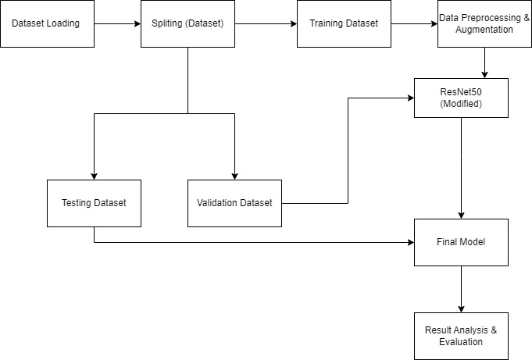

*Fig 3.1 – Block Diagram*

1. **Dataset**

In order to classify and identify disease on images that the model has never encountered before, deep learning models were tested and trained on images of plant leaves. We are using the “PlantVillage dataset,”[15] which is a publicly available dataset containing images of diseased and healthy plant leaves. The dataset includes images of 38 different plant species, each with multiple categories of disease, as well as images of healthy leaves. The dataset was created to help with the development of machine learning models for plant disease detection and has been widely used in research.

TABLE II. Dataset details

|  |  |
| --- | --- |
| **Attribute** | **Value** |
| Number of classes | 38 (37 diseased, 1 healthy) |
| Total number of images | 54,306 |
| Image size | 256x256 pixels |
| Image format | JPG |
| Source | Publicly available |

1. **Data Splitting**

The data is initially divided into three parts: training, validation, and testing, with a percentage ratio of 80%, 10%, and 10%, respectively. This split ratio was selected based on a study [16].

The training set comprises 80% of the data, which is 34,727 samples. The validation set is 10% of the data, which is 8,702 samples, and the testing set is also 10% of the data, which is 10,876 samples. The testing set is used for model evaluation and prediction, while the training set is further split into training and validation sets with ratios of 80% and 20%, respectively, to assess whether the model is overfitting.

The Plant Village training dataset consists of 38,400 RGB images of 14 crop species, with 2,400 images per class. Each image is labelled as "healthy" or "diseased" and belongs to a specific crop species. The images have varying resolutions and aspect ratios, ranging from 256 x 256 to 2,560 x 1,920, and captured in a controlled environment. The dataset also includes metadata files containing information about the crop species, type of disease, and severity of the disease, which can help in developing more complex models.

The validation set of the Plant Village dataset contains 16,906 labelled images of 14 crop species, with 1,066 images per class. It is a subset of the training set, with some images from the training set also present in the validation set. The validation set is used to evaluate the model's performance during training and to test its ability to generalize to new, unseen data, which helps to prevent overfitting.

1. **Data Pre-Processing**

Image Pre-Processing enhances the picture data required for image categorization. There are geometric alterations of photographs used in Pre-Processing techniques, such image translation, picture scaling, and rotation. In the Pre-Processing processes, we have scaled down all the photos' resolutions to 256*256 pixels. It must guarantee that all photos are of the same resolution. Then data rescaling can normalize the pixel values of images from the range **[0, 255]** to **[0, 1]**, making it easier for the model to learn and reducing the impact of outliers.

1. **Data Augmentation**

In data augmentation by applying random transformations to images, we can create new images that are similar to the originals, but not identical. For example, we can flip an image horizontally to create a mirror image or rotate an image to simulate a different viewpoint. By doing this, we can increase the diversity of the training data and help the model to learn more generalizable features.

We first define a set of data augmentation parameters and specify a range of random transformations to apply to the input images, including rotations, translations, shears, zooms, and flips. We also specify the fill mode to use when creating new pixels to fill in any empty space that may be created by the transformations.

1. **ResNet50 (Base Architecture)**

In transfer learning, models such as AlexNet, AlexNetOWTBn, GooLeNet, Overfeat, and VGG are commonly used due to their stacked convolutional layers. However, deep CNN networks present several challenges, including difficulties in network optimization, the vanishing gradient problem, and degradation problems. To address these challenges, the Residual network (ResNet) introduced a new idea that has proven effective in solving complex tasks and increasing detection accuracy. ResNet aims to overcome the training difficulties encountered in deep CNN networks, such as saturation and accuracy degradation.

In this paper, we utilized the ResNet50 architecture, which consists of 50 layers of residual networks, to address these challenges and improve performance. ResNet-50 is a powerful pre-trained convolutional neural network architecture that has already learned to recognize a wide range of features in natural images. By leveraging the knowledge that ResNet-50 has learned from the ImageNet dataset, we can use transfer learning to develop a plant disease detection model that performs well on a new dataset of plant images with diseases.

To accomplish this, we first remove the fully connected layer(s) from the pre-trained ResNet-50 model and add our own fully connected layer(s) on top of the convolutional layers. We then freeze the weights of the pre-trained ResNet-50 model to ensure that we do not lose the knowledge it has already learned. We train the new fully connected layer(s) on our own plant disease dataset while keeping the convolutional layers of the ResNet-50 model fixed. Finally, we fine-tune the weights of the ResNet-50 model by unfreezing some of its layers and continuing to train the entire network on our own dataset. This transfer learning approach can save a lot of time and effort while providing excellent results for plant disease detection.

1. **Fine Tuning**

We are using fine-tuning and freezing layers to leverage the features learned by the model on the ImageNet dataset for plant disease classification. Fine-tuning involves adapting a pre-trained model that has already been trained for a problem of a similar nature, which allows us to reuse previously acquired information and reduce the amount of effort needed. In addition, by freezing the layers before the 154th layer of ResNet50, we can leverage the pre-trained weights of these layers, which have learned generic features that are likely to be useful for the new task.

We have set specific parameters for fine-tuning, including a batch size of 32, 20 epochs, 1 validation step, an Adam optimizer with a learning rate of 0.00001. These values may need to be adjusted based on the performance of the model during training. By fine-tuning the remaining trainable layers in ResNet50, we can classify healthy and diseased plants and evaluate the performance of the model to determine the most effective model for plant disease detection.

This approach provides insights into the potential applications of transfer learning and freezing layers for image classification tasks, where we can leverage pre-trained models and fix the weights of some layers to improve performance and reduce overfitting. Overall, by combining fine-tuning and freezing layers, we are striking a balance between leveraging the pre-trained weights of the model and allowing it to adapt to the new task, which is a common strategy in transfer learning.

TABLE III. Fine Tuning Parameters

|  |  |
| --- | --- |
| **Parameter** | **Value** |
| Batch size | 32 |
| Epoch | 20 |
| Validation steps | 1 |
| Optimizer | Adam (adaptive moment estimation) |
| Learning rate | 0.00001 |
| Loss function | Sparse categorical entropy |

1. **Training:**

During the training phase, the model is trained on batches of augmented images, and the parameters of the model are iteratively adjusted to minimize a loss function. At each epoch, the training data is divided into batches, and the model is fed a batch of images. For each image, the model predicts the probability of each class (healthy or diseased), and these predictions are compared to the actual class label of the image. The difference between the predicted and actual labels is quantified using a loss function, such as sparse categorical cross-entropy.

The backpropagation algorithm is then used to calculate the gradients of the loss function with respect to each of the model's parameters. These gradients are then used to adjust the parameters in the opposite direction of the gradients, which updates the loss function. This process is repeated over all epochs, and the model is validated on a separate set of images called the validation set. The goal of training is to find the set of model parameters that minimize the loss function on the training data. However, it's important to note that overly complex models with too many parameters can lead to overfitting. To prevent overfitting, early stopping and regularization techniques are used.

During training, the batch size, the number of steps per epoch, and the number of epochs are all important hyperparameters that need to be set appropriately. The Early Stopping and Model Checkpoint call backs are two techniques used to optimize the training process by adjusting the number of epochs and saving the best model based on the validation loss. Once the training is complete, the trained model can be used to classify new images into their respective classes. The performance of the model can be evaluated using various metrics such as accuracy, precision, and recall which measure the model's ability to correctly classify images. The best model is usually chosen based on the performance on the testing set, which is a set of images not seen by the model during training or validation. In the testing stage, the test dataset which was earlier generated by splitting is used with the final CNN model to find out the performance of our model using various performance metrics such as accuracy, precision, recall, F1 score, and confusion matrix.

**ResNet Model Architecture**

Kaiming He et al. [17] presented the residual network (ResNet) in 2015 as a deep convolutional neural network architecture that was created to address the issue of vanishing gradients that occurs in very deep neural networks. One of the most often used deep learning architectures is ResNet, which comes in 50-, 101-, and 152-layer variations. The skip connections are made feasible by residual blocks, which have two or three convolutional layers and a skip connection that multiplies the input by the block's output. This architecture allows the network to learn residual functions rather than the desired input-output mapping.

ResNet helps to tackle challenging problems and improves detection precision. ResNet aims to address the saturation and accuracy degradation that occur during the deep CNN training process. We used the ResNet50 with our output layers , architecture in this paper. 50 layers of residual networks made up ResNet50. ResNet50 architecture is depicted in Figure below.

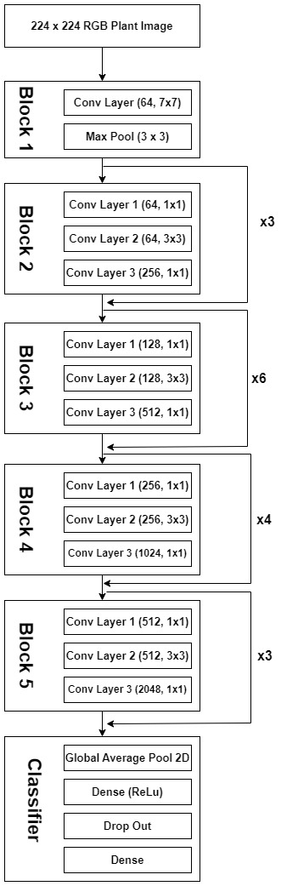

*Figure 3.2: Generic architecture of Resnet50*

ResNet50 is a deep convolutional neural network architecture used for image classification, object detection, and other computer vision tasks. It consists of 50 convolutional layers, and it builds upon the original ResNet architecture by introducing several improvements, including bottleneck layers and skip connections.

Here is a brief explanation of each layer in ResNet50:

1. **Input layer:** The input layer takes the raw image data as input and prepares it for processing by the rest of the network.
2. **Convolutional layer:** The first layer applies a convolution operation to the input image, which applies a set of filters to the input to extract features from it. This layer has 64 filters with a kernel size of 7x7.
3. **Batch normalization layer:** The output of the convolutional layer is passed through a batch normalization layer, which normalizes the output to improve the stability and performance of the network.
4. **ReLU activation layer:** The output of the batch normalization layer is passed through a rectified linear unit (ReLU) activation layer, which introduces non-linearity into the network.
5. **Max pooling layer:** The output of the ReLU activation layer is then passed through a max pooling layer, which reduces the spatial size of the feature maps and helps to make the network more robust to variations in the input.
6. **Bottleneck layers:** The majority of the ResNet50 V2 network consists of bottleneck layers, which are designed to reduce the computational cost of the network while maintaining its accuracy. Each bottleneck layer consists of three sub-layers: a 1x1 convolutional layer, a 3x3 convolutional layer, and another 1x1 convolutional layer. These layers are used to reduce the number of channels in the input, apply a non-linear activation function, and then increase the number of channels again.
7. **Output layer:** The output layer is a fully connected layer that produces the final output of the network. For image classification, this layer typically has a softmax activation function that produces a probability distribution over the possible classes.

The bottleneck building block is used in the 50-layer ResNet. A bottleneck residual block, also referred to as a "bottleneck", uses 1*1 convolutions to cut down on the number of parameters and matrix multiplications. This makes each layer's training significantly faster. Instead of using a stack of two levels, it employs three layers. As listed in the table below, the 50-layer ResNet design consists of the following components:

* A 7×7 kernel convolution alongside 64 other kernels with a 2-sized stride.
* A max pooling layer with a 2-sized stride.
* 9 more layers 3×3,64 kernel convolution, another with 1×1,64 kernels, and a third with 1×1,256 kernels. These 3 layers are repeated 3 times.
* 12 more layers with 1×1,128 kernels, 3×3,128 kernels, and 1×1,512 kernels, iterated 4 times.
* 18 more layers with 1×1,256 cores, and 2 cores 3×3,256 and 1×1,1024, iterated 6 times.
* 9 more layers with 1×1,512 cores, 3×3,512 cores, and 1×1,2048 cores iterated 3 times (up to this point the network has 50 layers)

Average pooling, followed by a fully connected layer with 1000 nodes, using the softmax activation function.

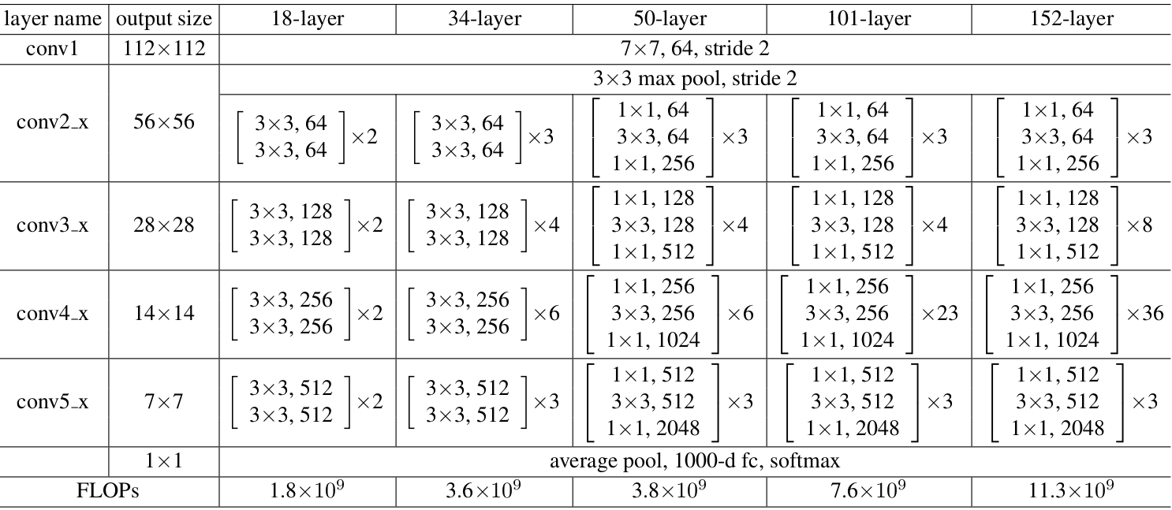

*Figure 3.4: Average Pooling*

The architecture, which uses 33 filters, is comparable to the VGG net [18], however ResNet is nearly 8 times deeper. The ResNet-50 model with recurrent connections as residual blocks and transfer learning is deployed using 50 parameterized layers.

A network-in-network (NIN) architecture called ResNet is relying on a large number of stacked residual units. The network was built using this set of residual units as its building pieces. Building blocks that make up the ResNet Architecture are made up of a group of residual units. The convolution, pooling, and layer components make up the residual units.

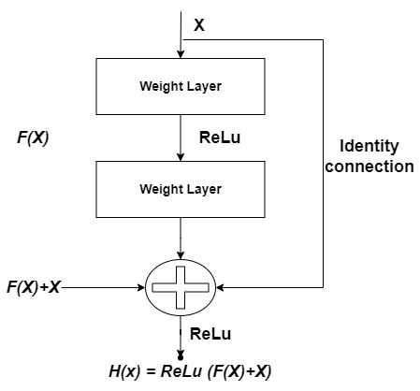

*Figure 3.5: Residual Block of Deep Residual Network [17]*

Here, each unit can be expressed as,

$H\left(x\right)=ReLU\left(F\left(x\right)+x\right)$ (1)

where, $H\left(x\right)$ is an identifying mapping of ReLU.

$x$ are the inputs to the first of layers.

$H\left(x\right)-x$ is assuming the input and output are of same dimensions.

$F\left(x\right)+x$ is the original function.

Now for nth units,

$y_{n}=H\left(x_{n}\right)+f\left(x_{n}, w\right)$ (2)

$x_{n+1}=f\left(y_{n}\right)$ (3)

$H\left(x_{n}\right)=x_{n}$ (4)

Where, $x_{n}$ is the input,

$x_{n+1}$ is the output of nth units,

$f$ Is the residual function of nth units.

$H\left(x_{n}\right)$ is an identifying mapping of ReLU

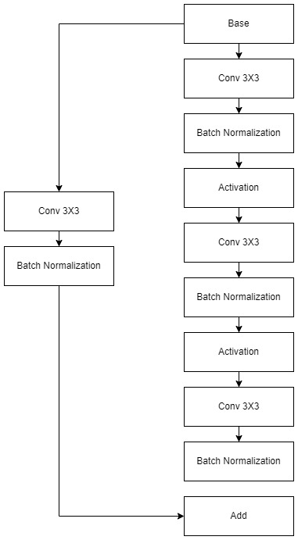 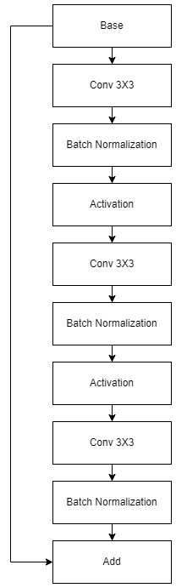

*Figure 3.6: Convolution Block and Identity Block*

There are two types of blocks in ResNet-50, Identity Block and Convolution Block

If and only if the value of "*x*" is added to the output layer,

$input size == output size$ (6)

If not, we include a "convolutional block" in the shortcut path to make the input and output sizes equal.

There are two approaches to equalise the input and output sizes: Conducting 1*1 convolutions and padding the input volume.

The size of the output layer is determined using,

${\left[\left\{\frac{n+2p-f}{s}\right\}+1\right]}^{2}$ (7)

Where, $n=$ input image size,

$p=$ padding,

$s=$ stride,

$f=$ number of filters.

For, 1*1 convolutional layer, size of output layer,

${(\frac{n}{2})}^{2}$ (8)

Given, the input size is ‘n.’

1. **Experimental Analysis**
   1. **Dataset**

The Plant Village dataset is a publicly available dataset consisting of images of diseased and healthy crops, along with their corresponding labels. The dataset was created by researchers at Penn State University, including David Hughes and Marcel Salathé, and was released in 2016. The images in the dataset were collected from a variety of sources, including public repositories and private collections. The Plant Village dataset contains more than 54,000 images of 14 different crop species, including tomato, corn, wheat, and potato. Within each crop species, there are multiple categories of both healthy and diseased plants, resulting in a total of 38 different classes. The dataset is relatively balanced, with roughly equal numbers of images for each class.

*Table Description*: This table includes information about different plant classes, the number of samples in each class, and some potential challenges that each class may face in plant village dataset.

TABLE IV. Dataset Details

|  |  |  |
| --- | --- | --- |
| **Class Name** | **Number of Samples** | **Challenges** |
| Apple | 1447 | Fire blight, powdery mildew, apple scab |
| Bell Pepper | 1754 | Bacterial spot, anthracnose, Phytophthora blight |
| Blueberry | 151 | Mummy berry, stem blight, rust |
| Cherry | 790 | Cherry leaf spot, brown rot, powdery mildew |
| Corn | 2267 | Corn smut, common rust, northern corn leaf blight |
| Grape | 2776 | Black rot, powdery mildew, downy mildew |
| Orange | 550 | Citrus greening disease, citrus canker, black spot |
| Other citrus | 256 | Citrus blackfly, citrus rust mite, root rot |
| Peach | 2746 | Peach leaf curl, bacterial spot, brown rot |
| Pepper | 223 | Bacterial leaf spot, blossom end rot, bacterial canker |
| Potato | 2566 | Late blight, early blight, common scab |
| Raspberry | 216 | Raspberry leaf curl, cane blight, powdery mildew |
| Soybean | 509 | Soybean rust, brown stem rot, sudden death syndrome |
| Spinach | 203 | Downy mildew, white rust, leaf miner |
| Squash | 814 | Powdery mildew, downy mildew, bacterial wilt |
| Strawberry | 1463 | Powdery mildew, gray mold, verticillium wilt |
| Tomato | 1591 | Late blight, early blight, septoria leaf spot |
| Tomato (leaf) | 138 | Yellow leaf curl virus, bacterial speck, bacterial spot |

**Sample Images:**

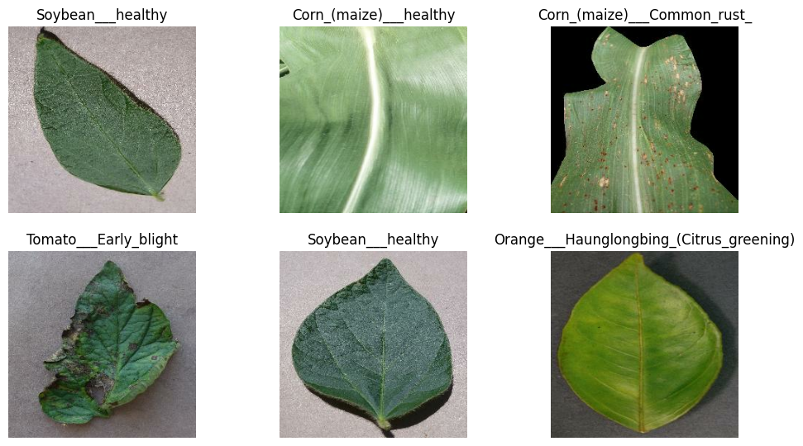

* 1. **Performance Measures**
     1. **Accuracy**

Since, we are using binary classification problem, here accuracy is the number of correctly classified instances is the sum of the number of true positives (TP) and true negatives (TN), while the total number of instances is the sum of TP, TN, false positives (FP), and false negatives (FN).

Accuracy = (Number of correctly classified instances) / (Total number of instances)

$Accuracy =\frac{\left(TP+TN\right)}{\left(TP+TN+FP+FN\right)}$ (9)

Where,

*TP*: True Positive - number of correctly predicted positive instances.

*TN*: True Negative - number of correctly predicted negative instances

*FP*: False Positive - number of incorrectly predicted positive instances.

*FN*: False Negative - number of incorrectly predicted negative instances.

* + 1. **Precision**

Precision is a metric used to evaluate the performance of a classification model, particularly in the context of binary classification problems. It measures the proportion of true positive predictions among all the positive predictions made by the model. In other words, it is the ratio of the number of true positives (TP) to the sum of true positives and false positives (FP).

In simpler terms, precision is a measure of how many of the instances predicted to be positive by the model are actually positive.

$precision=\frac{TP}{\left(TP+FP\right)}$ (10)

Where,

*TP*: True Positive - number of correctly predicted positive instances.

*FP*: False Positive - number of incorrectly predicted positive instances.

* + 1. **Recall**

Recall, also known as sensitivity or true positive rate, is a metric used to evaluate the performance of a classification model, particularly in the context of binary classification problems. It measures the proportion of true positive predictions among all the actual positive instances in the dataset. In other words, it is the ratio of the number of true positives (TP) to the sum of true positives and false negatives (FN).

In simpler terms, recall is a measure of how many of the actual positive instances in the dataset are correctly identified by the model as positive.

$Recall=\frac{TP}{\left(TP+FN\right)}$ (11)

Where,

*TP*: True Positive - number of correctly predicted positive instances.

*FN*: False Negative - number of incorrectly predicted negative instances.

TABLE IV. summary of measures

|  |  |  |  |  |
| --- | --- | --- | --- | --- |
| **Measure** | **Range** | **Acceptable Value** | **Poor** | **Good** |
| Accuracy | 0 to 100% | 70-100% | Below 70% | Above 90% |
| Precision | 0 to 100% | 60-80% | Below 60% | Above 80% |
| Recall | 0 to 100% | 60-80% | Below 60% | Above 80% |

* 1. **Result of Proposed Method**
     1. **Subjective Result**
        1. **ResNet50**

ResNet50 has the highest accuracy among the models listed, with a score of 95.68%. Its precision and recall values are also very high, indicating that it is able to correctly classify both diseased and healthy plants with a high degree of accuracy. This is likely due to its more complex architecture, which allows it to learn more complex representations of the input data. Overall, ResNet50 is a strong choice for plant disease detection tasks.

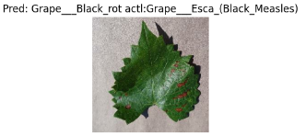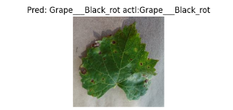

* + - 1. **Modified Resnet50**

Resnet50 using transfer learning is a variant of Resnet50 that has been fine-tuned on the plant disease detection task, resulting in an even higher accuracy of 98.72%. Its precision and recall values are also very high, indicating that it is able to correctly classify both diseased and healthy plants with a high degree of accuracy. This model is a good choice for tasks where high accuracy is essential, but it may require more computational resources and training time due to its complexity.

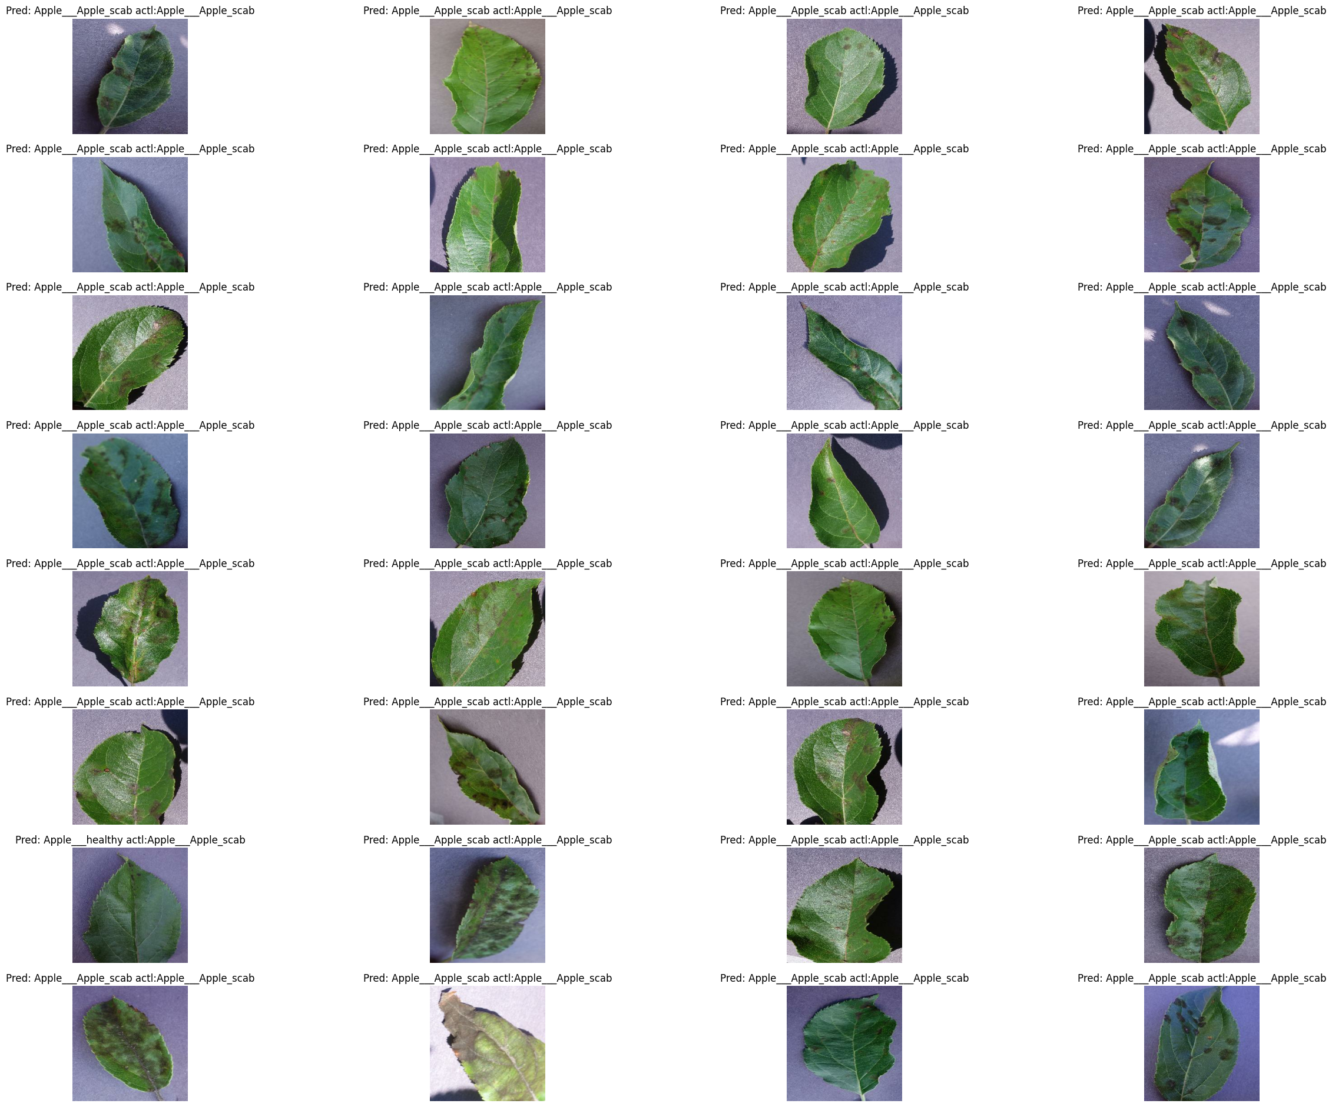

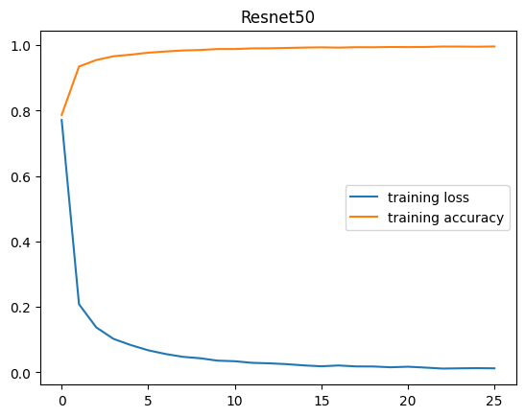 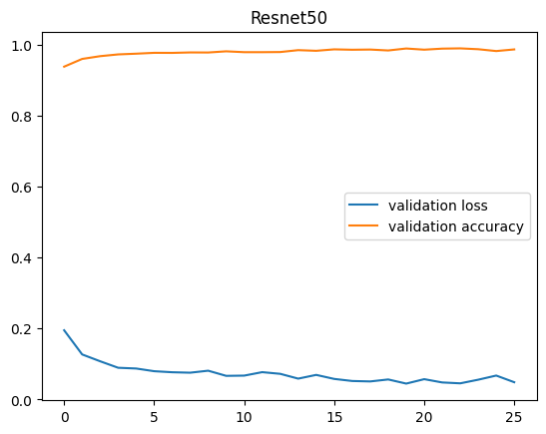

* + - 1. **InceptionV3**

InceptionV3 has a more complex architecture compared to VGG16, but slightly lower accuracy at 91.68%. However, its precision and recall values are high, indicating that it is able to correctly classify both diseased and healthy plants with a high degree of accuracy. InceptionV3 is designed to handle input images of various sizes, which may make it a good choice for datasets with a large variation in image sizes. This model is a good choice for tasks where high accuracy is essential, but a simpler architecture is preferred over ResNet50.

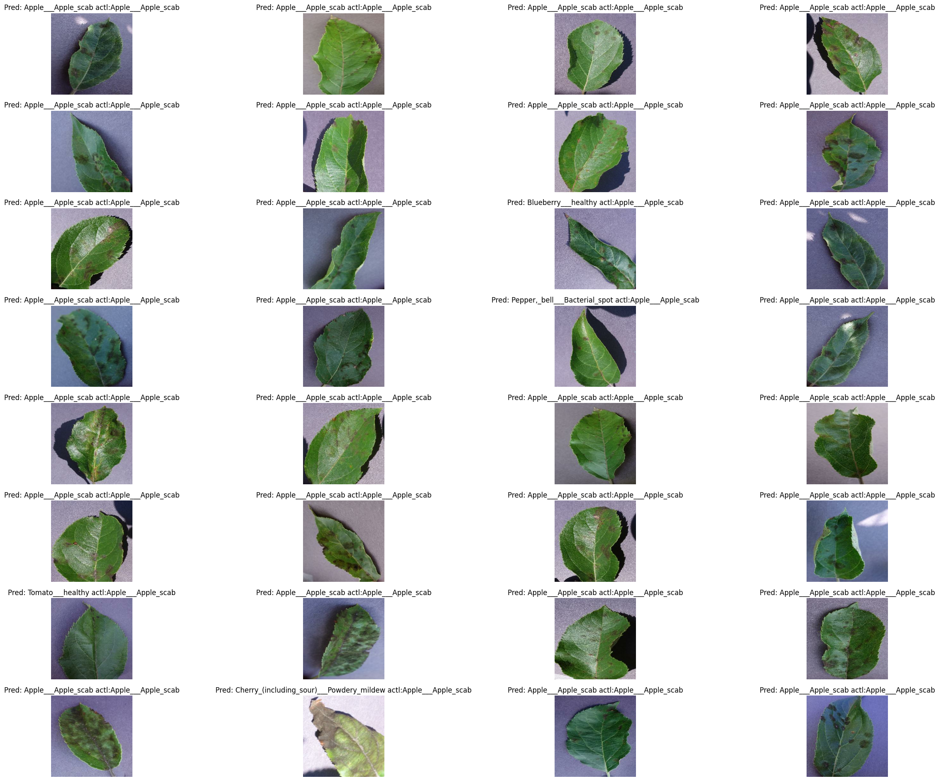 

* + - 1. **VGG16**

VGG16 is a simpler model architecture compared to ResNet50 and InceptionV3, which may explain why its accuracy is slightly lower at 90.33%. However, its precision value is higher than the other models, indicating that it is better at correctly identifying diseased plants. The recall value is also lower, suggesting that it may struggle to correctly identify healthy plants. VGG16 is a good choice for tasks where computational resources are limited, or when simplicity is preferred over high accuracy.

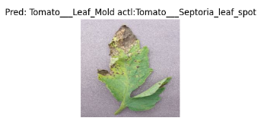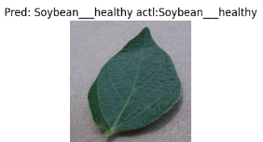

* + 1. **Objective Result**

|  |  |  |  |  |
| --- | --- | --- | --- | --- |
| **S.N** | **Model** | **Testing Accuracy** | **Precision** | **Recall** |
| 1 | Normal CNN model | 91.76% | 91.93% | 91.76% |
| 2 | Inception V3 | 91.68% | 91.95% | 91.68% |
| 3 | Vgg16 | 90.33% | 91.49% | 90.33% |
| 4 | Resnet 50 | 95.68% | 95.98% | 95.68% |
| 5. | Resnet50 (Fine-tuned) | 98.72% | 98.78% | 98.72% |

From the metrics table we observed that Resnet50 using Transfer Learning gives the best accuracy.

ResNet50 has ability to effectively learn and extract features from complex image datasets. By leveraging its deep learning capabilities, ResNet50 is able to identify patterns and textures that are indicative of specific diseases. Hence it is good for plant disease detection.

* 1. **Comparison of Proposed method with Existing Methods**

|  |  |  |  |  |
| --- | --- | --- | --- | --- |
| **S.N** | **Model** | **Accuracy** | **Precision** | **Recall** |
| 1. | **Base paper** model -Resnet50  Using Transfer Learning [8] | 96% | - | - |
| 2. | **Proposed** model -Modified Resnet50v2 using transfer Learning | **98.72%** | 98.78% | 98.72% |
| 3. | Efficient Deep learning model [7] | 74.10% | 88.13% | 94.06% |
| 4. | Deep CNN [12] | 98.18% | 98.31% | 98.16% |
| 5. | Efficient De deep learning model, Backbone Network, BiFPN Network [7] | 74.10% | 88.13% | 94.06% |
| 6. | CNN model with the integration of computer vision (CV) [13] | 93.8% | 99.1% | 95.9% |

* 1. **Conclusion**

In conclusion, the early detection of plant diseases is vital for ensuring sustainable agriculture and food security. In recent years, deep learning-based approaches have shown great promise in this area. Our study proposes a modified ResNet50 using transfer learning approach for plant disease detection, which we compared to existing methods.

The results of our experiments demonstrated that the proposed method outperformed the base paper model and other existing methods, exhibiting superior accuracy, precision, and recall. This finding indicates that the modified ResNet50 using transfer learning approach is an exceptionally effective and efficient method for detecting plant diseases. Additionally, our proposed approach can be incorporated into mobile applications, allowing for increased accessibility for farmers in remote areas. The development and deployment of this model has the potential to significantly contribute to sustainable agriculture and food security, both of which are critical issues faced by the world today. Future research can focus on improving the model's performance by incorporating larger datasets, refining the transfer learning approach, and exploring other deep learning architectures.

In conclusion, our proposed modified ResNet50 using transfer learning approach is a reliable and effective tool for the early detection and management of plant diseases, offering a promising solution to the challenges faced in agriculture and food production.

**References**

[1] Adeleke, B. S., & Babalola, O. O. (2022). Roles of plant endosphere microbes in agriculture-a review. *Journal of Plant Growth Regulation*, *41*(4), 1411-1428.

[2] Khakimov, A., Salakhutdinov, I., Omolikov, A., & Utaganov, S. (2022). Traditional and current-prospective methods of agricultural plant diseases detection: A review. In *IOP Conference series: earth and environmental science* (Vol. 951, No. 1, p. 012002). IOP Publishing.

[3] Talreja, R., Jawrani, V., Watwani, B., Sengupta, S., Rohera, P., & Raghuwanshi, K. S. (2022, May). AgriCare: An Android Application for Detection of Paddy Diseases. In *2022 3rd International Conference for Emerging Technology (INCET)* (pp. 1-6). IEEE.

[4] Pantazi, X. E., Moshou, D., & Tamouridou, A. A. (2019). Automated leaf disease detection in different crop species through image features analysis and One Class Classifiers. *Computers and electronics in agriculture*, *156*, 96-104.

[5] Yatoo, A. A., & Sharma, A. (2021, November). A Novel Model for Automatic Crop Disease Detection. In *2021 Sixth International Conference on Image Information Processing (ICIIP)* (Vol. 6, pp. 310-313). IEEE.

[6] Ma, J., Du, K., Zheng, F., Zhang, L., Gong, Z., & Sun, Z. (2018). A recognition method for cucumber diseases using leaf symptom images based on deep convolutional neural network. *Computers and electronics in agriculture*, *154*, 18-24.

[7] R. K. Lakshmi and N. Savarimuthu, "PLDD—A Deep Learning-Based Plant Leaf Disease Detection," in IEEE Consumer Electronics Magazine, vol. 11, no. 3, pp. 44-49, 1 May 2022, doi: 10.1109/MCE.2021.3083976.

[8] Venkataramanan, Aravindhan & Agarwal, Pooja. (2019). Plant Disease Detection and Classification Using Deep Neural Networks.

[9] Syed-Ab-Rahman, S.F., Hesamian, M.H. & Prasad, M. Citrus disease detection and classification using end-to-end anchor-based deep learning model. *Appl Intell* **52**, 927–938 (2022).

[10] M. Kathiravan, K. H. Priya, S. Sreesubha, A. Irumporai, V. S. Kumar, and V. V. Reddy, "ML Algorithm-Based Detection of Leaf Diseases," 2022 4th International Conference on Smart Systems and Inventive Technology (ICSSIT), Tirunelveli, India, 2022, pp. 1396-1400, doi: 10.1109/ICSSIT53264.2022.9716430.

[11] Wu, Y. (2021). Identification of maize leaf diseases based on convolutional neural network. In *Journal of physics: Conference series* (Vol. 1748, No. 3, p. 032004). IOP Publishing.

[12] Mondal, Joyanta & Islam, Md & Zabeen, Sarah & Islam, A. B. M. Alim Al & Noor, Jannatun. (2022). Plant Leaf Disease Network (PLeaD-Net): Identifying Plant Leaf Diseases through Leveraging Limited-Resource Deep Convolutional Neural Network.

[13] Ullah, F., Khan, R. U., Khan, K., Albattah, W., & Qamar, A. M. (2021). Image-based detection of plant diseases: From classical machine learning to deep learning journey. Wireless Communications and Mobile Computing, 2021, 5541859.

[14] Jiang, F., Lu, Y., Chen, Y., Cai, D., & Li, G. (2020). Image recognition of four rice leaf diseases based on deep learning and support vector machine. *Computers and Electronics in Agriculture*, *179*, 105824.

[15] Hughes, D., & Salathé, M. (2015). An open access repository of images on plant health to enable the development of mobile disease diagnostics. *arXiv preprint arXiv:1511.08060*.

[16] Mohanty, S. P., Hughes, D. P., & Salathé, M. (2016). Using deep learning for image-based plant disease detection. *Frontiers in plant science*, *7*, 1419.

[17] He, K., Zhang, X., Ren, S., & Sun, J. (2016). Deep residual learning for image recognition. In *Proceedings of the IEEE conference on computer vision and pattern recognition* (pp. 770-778).

[18] Simonyan, K., & Zisserman, A. (2014). Very deep convolutional networks for large-scale image recognition. *arXiv preprint arXiv:1409.1556*.

[19] Dataset link- https://github.com/spMohanty/PlantVillage-Dataset/tree/master/raw/color